24ADC001 - BUSINESS INTELLIGENCE
LAB ASSIGNMENT_21.08.2026
LAB 1 - POWER BI
Screenshot of Dashboard: .pbix file attached
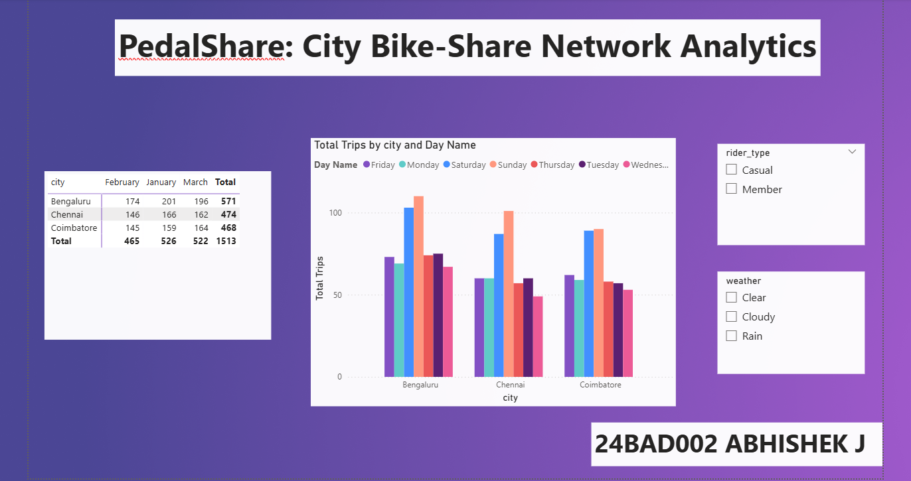
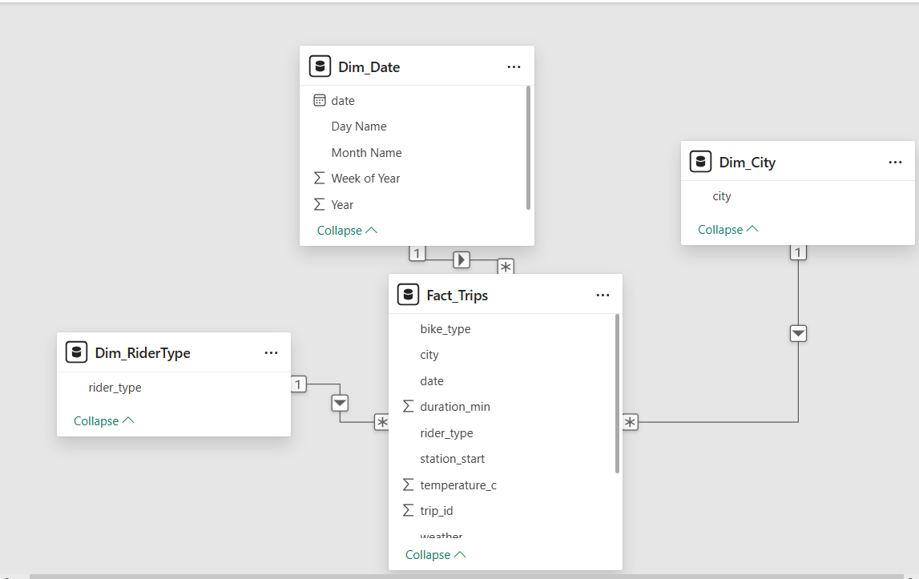
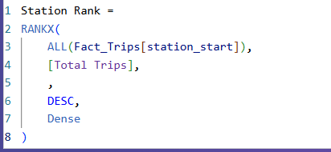
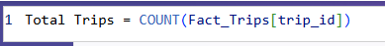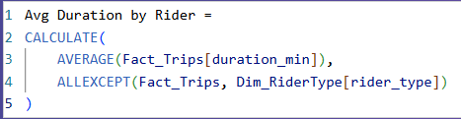
WRITE-UP:
Does casual ridership really spike on weekends across all three cities, or is that pattern driven by just one city?
The analysis confirms that the weekend casual ridership spike is not driven by a single city, but is a consistent, system-wide pattern across all three markets (Bengaluru, Chennai, and Coimbatore).
Over the 90-day evaluation period (comprising 64 weekdays and 26 weekend days), casual ridership increases significantly on weekends across every location:
- Bengaluru: Casual trips jump from an average of 1.73 trips/day on weekdays (111 total) to 5.46 trips/day on weekends (142 total)-a 3.15x increase.
- Chennai: Casual trips jump from an average of 1.33 trips/day on weekdays (85 total) to 4.77 trips/day on weekends (124 total)-a 3.59x increase.
- Coimbatore: Casual trips jump from an average of 1.18 trips/day on weekdays (76 total) to 4.35 trips/day on weekends (113 total)-a 3.66x increase.
Additionally, average casual trip durations increase across all three cities on weekends (rising from ~29 minutes on weekdays to ~38 minutes on weekends), showing that casual users not only take more trips but also ride for longer durations during weekends.
The weekend casual ridership spike is a shared trend across the entire network. Operations should focus fleet rebalancing and casual pass promotions uniformly across all three cities heading into weekends.
SUPPORTING VISUAL:
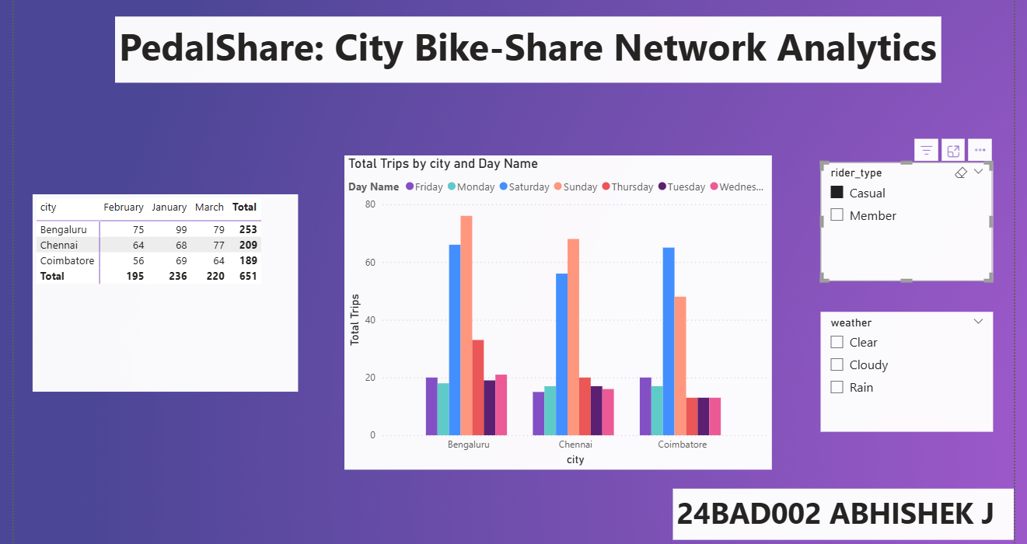

LAB 2 — TABLEAU
DASHBOARD SCREENSHOT: .twb attached
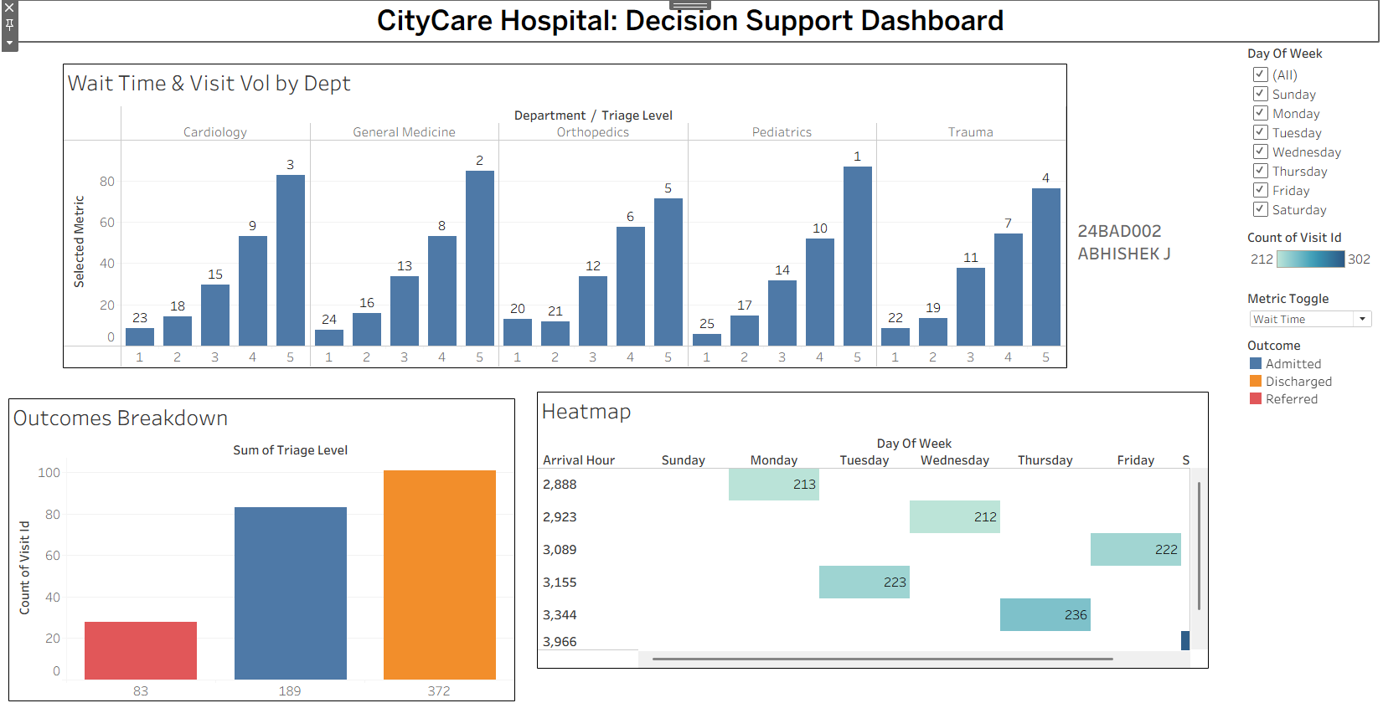
RECOMMENDATION:
Emergency Department Staffing Decision Framework
Determining when to add ER staff at CityCare Hospital is a semi-structured decision.
The decision contains clear structured elements that the Decision Support System (DSS) automates. By analyzing historical visit counts, triage levels, and wait times, the dashboard provides quantifiable evidence of predictable bottlenecks-specifically revealing volume spikes and wait-time surges during weekend nights (6 p.m.–11 p.m.). These data-driven metrics establish objective baselines for when additional coverage is mathematically justified, replacing subjective hunches with empirical proof needed for budget approval.
However, the decision also involves critical unstructured elements that historical data alone cannot resolve. A dashboard cannot account for real-time, unpredictable variables such as sudden mass-casualty incidents, severe weather shifts, unexpected staff illness, strict fiscal budget caps, or clinician burnout.
Therefore, the DSS serves as a diagnostic tool that isolates historical operational trends and provides evidence to justify staffing requests. The emergency department manager’s judgment must complement the system by evaluating live operational context, human factors, and institutional constraints. Ultimately, the DSS identifies where and when staffing gaps consistently occur, while the manager retains final authority on how and whether to deploy personnel dynamically in real-world conditions.

LAB 3 - OPENAI (CHATGPT)
Deliverable 1 - Drafted Rule Set with Ticket Evidence
Rule 1 - Old Login URL
IF the customer cannot log in and is using an old bookmarked login URL from before the domain migration, THEN direct them to the current login URL and ask them to update their bookmark.
Ticket evidence: Tickets 4, 5, 35, 111, 133.

Rule 2 - Desktop Login / Stale Cookies
IF the customer can log in successfully on mobile but cannot log in on desktop, THEN clear the support platform's site-specific cookies and retry the login.
Ticket evidence: Tickets 6, 24, 40, 60, 62, 115, 122.

Rule 3 - Browser Extension Blocking Authentication
IF the customer's login session repeatedly expires within about two minutes, THEN check whether a browser extension is blocking authentication cookies, disable the suspected extension, and retry.
Ticket evidence: Tickets 15, 29, 32, 39, 48, 69, 70.

Rule 4 - False-Positive Account Suspension
IF the customer's account is suspended despite the customer reporting no policy violation, THEN check whether an automated fraud rule caused the suspension; if it is a false positive, escalate to Trust & Safety for whitelisting.
Ticket evidence: Tickets 11, 20, 59, 73, 98, 134.

Rule 5 - Delayed SMS Two-Factor Authentication
IF the customer does not receive their SMS two-factor authentication code, THEN check SMS delivery/gateway status; if delivery is delayed, offer the authenticator-app method as an immediate alternative.
Ticket evidence: Tickets 22, 27, 79, 108.

Rule 6 - Cancellation Submitted but Not Confirmed
IF a customer disputes a billing charge because they cancelled their subscription, THEN check the cancellation logs; if the cancellation was submitted but the second confirmation step was never completed, treat it as a workflow/UX issue and route it appropriately.
Ticket evidence: Tickets 1, 26, 30, 81, 96, 107.

Rule 7 - Duplicate Charge from Webhook Retry
IF the same invoice appears to have been charged twice, THEN check whether a failed payment webhook was retried; if the transactions are duplicates, refund the duplicate charge and flag the retry logic for engineering.
Ticket evidence: Tickets 3, 87, 105.

Rule 8 - Mid-Cycle Proration
IF a customer believes a mid-cycle plan upgrade was billed incorrectly, THEN recalculate the proration line by line and explain the calculation before issuing a refund or correction.
Ticket evidence: Tickets 7, 84, 90, 91, 100, 106, 114.

Rule 9 - Enterprise Invoice PDF Failure
IF an enterprise customer cannot generate an invoice PDF and the invoice contains more than eight line items, THEN treat it as the known invoice-template bug pattern and escalate it as a product issue rather than repeatedly asking the customer to retry.
Ticket evidence: Tickets 16, 71, 80, 82, 110, 116, 123.

Rule 10 - Expired Coupon
IF a customer's coupon does not apply at checkout, THEN verify the coupon's expiry date first; if it has expired, explain the reason and follow the applicable goodwill/replacement policy instead of treating it as a checkout-system failure.
Ticket evidence: Tickets 28, 31, 53.

Deliverable 2 - Cross-Check Results
Five tickets that were not used as the representative evidence above were selected and tested against the drafted rules.
Ticket | Issue | Rule Tested | Result | Cross-Check
39 | Login session expires repeatedly after ~2 minutes | Rule 3 | PASS | Rule correctly points to browser-extension/authentication-cookie checking.
60 | Login works on mobile but fails on desktop | Rule 2 | PASS | Rule correctly identifies the desktop cookie/cache pattern.
111 | Customer uses an old bookmarked login URL | Rule 1 | PASS | Rule correctly directs the agent to the current login URL.
100 | Customer believes upgrade proration is incorrect | Rule 8 | PASS | Rule correctly requires recalculation before issuing a refund.
114 | Customer disputes mid-cycle upgrade proration | Rule 8 | PASS | Rule correctly handles the same recurring proration pattern.
Cross-check conclusion
5/5 tickets passed. No drafted rule failed during the cross-check. The test also showed why rules need specific diagnostic conditions. For example, simply writing “IF customer cannot log in, THEN clear the cache” would be too broad. The stronger rule uses the specific clue that mobile login works while desktop login fails, making the recommended action much more reliable.

Deliverable 3 - Reflection Summary
Several parts of the veterans’ knowledge were easy to convert into clean rules because the tickets repeatedly contained the same observable symptom, diagnostic clue, and successful action. Examples include mobile-versus-desktop login failures leading to site-specific cookie clearing, two-minute session expiry pointing to a blocking browser extension, and enterprise invoice failures with more than eight line items indicating a template bug. These patterns are well suited to explicit IF-THEN rules because a new agent can recognize the trigger without needing years of experience.
The harder knowledge to reduce to a rule was the judgment involved in interpreting ambiguous customer reports. For example, a billing dispute may be a genuine user misunderstanding, a UX failure, or a backend defect; the agent has to inspect logs and understand context before choosing the right path. Similarly, deciding whether a performance problem is a customer-specific configuration issue or a wider capacity problem requires contextual evidence. Tacit knowledge therefore contains not only procedures, but also diagnostic judgment, exceptions, and confidence about when a rule should not be applied. The best guide should externalize repeatable patterns while preserving escalation points for cases that require human judgment.

LAB 4 – NOTEBOOKLM
EXECUTIVE SUMMARY:
NotebookLM was used to synthesize two sources: forecast_method_accuracy.csv, containing accuracy results for six forecasting methods across five regions, and region_notes.csv, containing qualitative descriptions of each region's demand pattern. The analysis shows that the best forecasting method differs by region. Holt-Winters is the lowest-MAPE method in North, East, West, and Central, while Simple Exponential Smoothing (SES) is the lowest-MAPE method in South. Therefore, the retailer should adopt a region-specific forecasting strategy rather than one universal model.
Region-by-Region Recommendations:
Region | Recommended Method | MAPE | RMSE | Demand Pattern | Interpretation
North | Holt-Winters (trend + seasonality) | 3.0% | 10.2 | Strong festive-season spikes (Oct–Nov) each year | Expected: recurring seasonal spikes align with Holt-Winters.
South | Simple Exponential Smoothing (SES) | 12.5% | 48.7 | Essentially flat month to month | Expected: SES assumes no trend or seasonality. SMA is also very close on MAPE (12.6%).
East | Holt-Winters (trend + seasonality) | 11.6% | 44.6 | Steady month-on-month growth; no clear seasonal pattern | Surprising: Holt-Winters wins despite no clear seasonality; sources do not prove why.
West | Holt-Winters (trend + seasonality) | 8.0% | 28.1 | Predictable summer dip every year; otherwise stable | Expected: recurring annual dip supports seasonal modeling.
Central | Holt-Winters (trend + seasonality) | 3.4% | 13.5 | Growing base demand plus sharp monsoon-season surge | Expected: trend plus recurring seasonal surge matches Holt-Winters.
Key Findings:
- North, West, and Central strongly support Holt-Winters because their analyst notes describe recurring seasonal events.
- South is the clearest example where added complexity does not improve performance: SES has the lowest MAPE at 12.5%, while SMA is nearly identical at 12.6% and has lower RMSE (41.8).
- East is the most surprising result. Holt-Winters records the lowest MAPE (11.6%) and RMSE (44.6), although the analyst reports no clear seasonal pattern.
- The East result should not be explained as proven hidden seasonality or overfitting. The provided sources establish the performance result, but not the exact causal reason.
- Regional specialization is preferable to a one-size-fits-all forecasting method because the demand patterns and measured winners differ.
Simple-Method Competitiveness: South
South is the single strongest example where simple forecasting is competitive. SES is the overall MAPE winner at 12.5%, while SMA is extremely close at 12.6% and has a lower RMSE of 41.8. By contrast, Holt's Method has 18.1% MAPE and Holt-Winters has 18.7%. The analyst note describes South as essentially flat month to month, which directly matches the assumptions of SES. The evidence supports using a simple method in South, where adding trend or seasonal components does not improve the measured forecasting accuracy.
East: The Surprising Result
East has steady month-on-month growth with no clear seasonal pattern, yet Holt-Winters is the measured winner (11.6% MAPE; 44.6 RMSE), followed by Holt's Method (12.9%; 50.8) and Linear Regression (17.8%; 70.3). The sources establish that Holt-Winters performs best historically, but they do not establish whether this is because of subtle seasonality, flexibility in tracking the growth pattern, or another factor. Such explanations should therefore be presented as possibilities rather than facts.
Management Recommendation
The retailer should deploy a region-specific forecasting strategy: Holt-Winters for North, East, West, and Central, and Simple Exponential Smoothing for South. This recommendation follows the lowest historical MAPE for each region while using the analyst notes to interpret whether the results are consistent with observed demand patterns.

Audio Overview link: https://notebook.google.com/notebook/cc0ca8ff-2f24-4a2a-9d75-fa6ee2deaf64/artifact/6256f3ad-73cf-4526-b112-e8897e207ea1?utm_source=nlm_web_share&utm_medium=google_oo&utm_campaign=art_share_1&utm_content=&utm_smc=nlm_web_share_google_oo_art_share_1_

Critique
NotebookLM genuinely added value by synthesizing the quantitative forecasting results with the qualitative analyst notes, rather than treating the spreadsheet and regional observations separately. The strongest example was the East region: the tool identified the unexpected result that Holt-Winters achieved the lowest MAPE despite the analyst reporting steady growth with no clear seasonal pattern. It also connected South's flat demand pattern with the strong performance of Simple Exponential Smoothing, showing why additional model complexity was unnecessary there. However, much of the region-by-region discussion simply restated information already visible in the spreadsheet, such as identifying the lowest MAPE for each region. Some explanations also went beyond what the sources directly established, particularly suggestions about hidden seasonality or overfitting. Most importantly, NotebookLM initially recommended Holt's Method for East despite Holt-Winters having the best measured accuracy, demonstrating that AI-generated recommendations still require verification against the original data. Overall, NotebookLM was most useful for cross-source interpretation, not for replacing direct analysis of the numerical results.
PPTX FILE ATTACHED

